|  |
| --- |
|  |
| **Auto solution**  **Surat 394101**  **7990553100**  **Parthilsavaliya20@gmail.com**  **Parthil-savaliya.github.io** |



Modules :-

Admin panel

Client Panel

* Admin panel :-
* Log In (Required)
* Details of Stocks (insert, update, delete, search)
* Details about cars(info of cars like interior , exterior , Features such as Safety, Mileage, color, body type , fuel, model ext...)
* Details of Sells (Generate Monthly Report, Download pdfs)
* Details of Employees (Insert, update, delete)
* Sign In (Add New User)
* 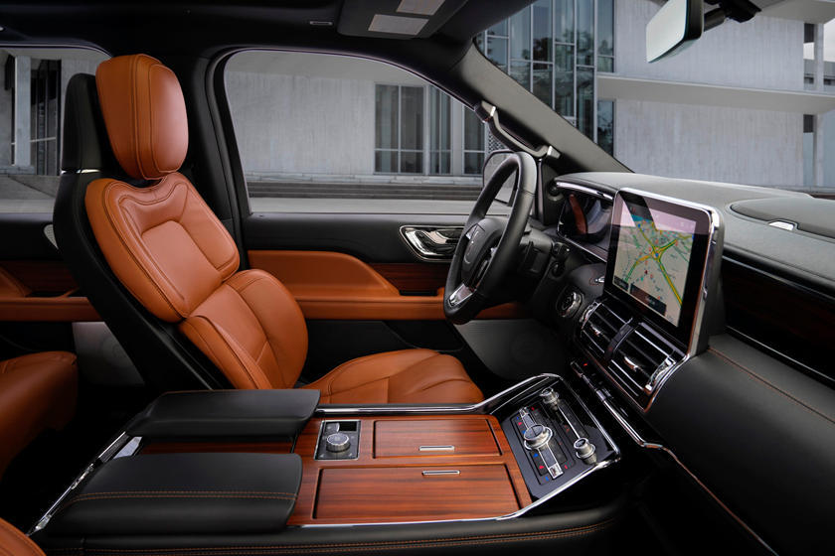Client :-
* Searching Cars
* Details of cars
* Car’s gallery
* Contact Us (WhatsApp,
* Instagram, Telegram)
* Download Purchase Receipts (Bill)
* Project profile :-

|  |  |
| --- | --- |
| **Project title:** | **Auto Solution** |
| Frontend: | Html, CSS, Bootstrap, Java-Script, J-Query,  Font-Awesome, Php |
| Backend: | MySQL |
| Browser: | Chrome, Firefox |
| Platform: | Vs-code |
| Documentation: | Microsoft Word |
| Internal guide: | Dr Hiral Patel |
| Submitted to: | Sutex Bank College of Computer Applications & Science |

* Objectives :-
* Auto solutions is a website for selling a car. Which provides quality of cars in Judicious price range with fascinate discounts.
* Auto solutions is famous for their after sells services. we give quality of services that’s why we become India’s largest car selling company.
* If a customer is served well, it brings other customers.
* System flow Diagram :-

* Data Flow Diagram :-

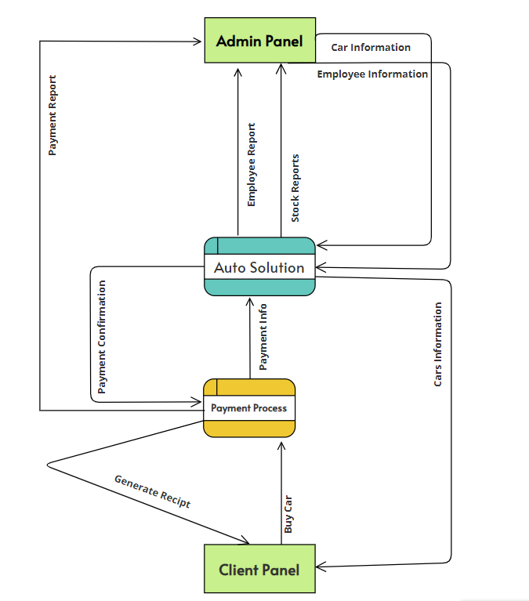

Context Level Data Flow Diagram

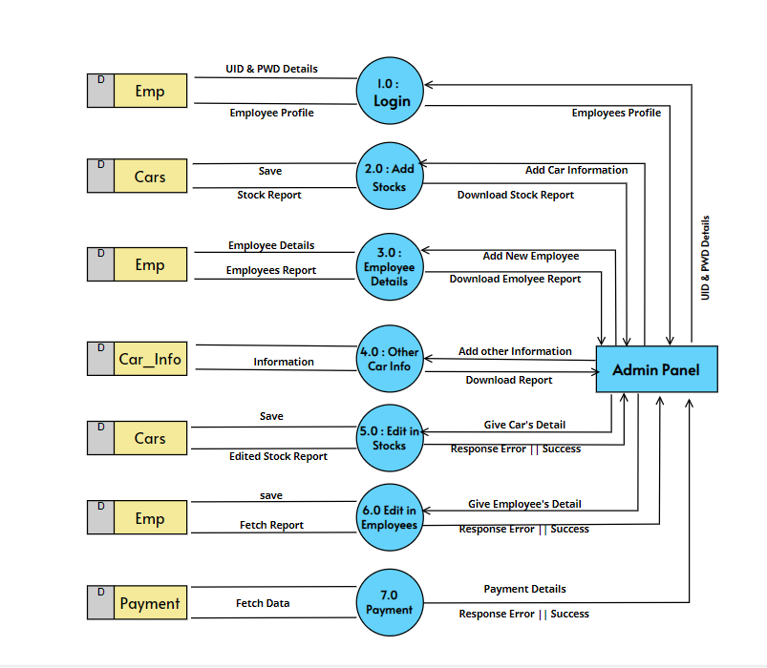

Admin Panel 1st Level Data Flow Diagram

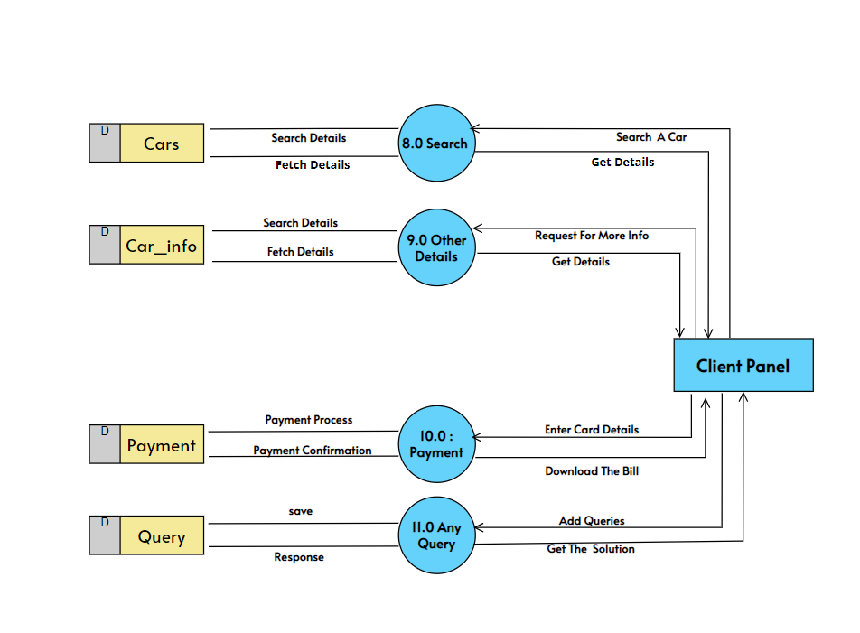

Client Panel 1St LevelData Flow Diagram

* Entity Relation Diagram :-

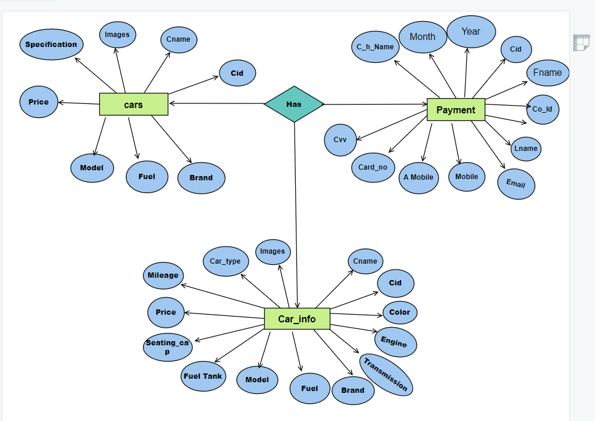

ER Diagram

* Database Design :-

|  |  |  |  |
| --- | --- | --- | --- |
| Cars | | | |
| No | Field Name | Data Type | Constraints |
| 1 | Cid | Auto Generate | Primary Key |
| 2 | Cname | String | Null |
| 3 | Images | String | Null |
| 4 | Specification | String | Null |
| 5 | Price | String | Null |
| 6 | Model | String | Null |
| 7 | Fuel | String | Null |
| 8 | Brand | String | Null |

|  |  |  |  |
| --- | --- | --- | --- |
| Car_**Info** | | | |
| No | Field Name | Data Type | Constraints |
| 1 | Cid | Auto Generate | Reference(cars) |
| 2 | Cname | String | Null |
| 3 | Images | String | Null |
| 4 | Car_type | String | Null |
| 5 | Price | String | Null |
| 6 | Model | String | Null |
| 7 | Fuel | String | Null |
| 8 | Brand | String | Null |
| 9 | Fuel Tank | String | Null |
| 10 | Seating Cap | String | Null |
| 11 | Engine | String | Null |
| 12 | Transmission | String | Null |

|  |  |  |  |
| --- | --- | --- | --- |
| Payment | | | |
| No | Field Name | Data Type | Constraints |
| 1 | Cid | Auto Generate | Reference(cars) |
| 2 | Co_id | Auto Generate | Primary |
| 3 | Fname | String | Null |
| 4 | Lname | String | Null |
| 5 | Email | String | Null |
| 6 | Mobile | Big Int | Null |
| 7 | A_Mobile | Big Int | Null |
| 8 | Card_h_Name | String | Null |
| 9 | Card_No | Big Int | Not Null |
| 10 | Cvv | Int | Null |
| 11 | Month | String | Null |
| 12 | Year | Int | Null |

|  |  |  |  |
| --- | --- | --- | --- |
| **Emp** | | | |
| No | Field Name | Data Type | Constraints |
| 1 | Srno | Auto Generate | Primary |
| 2 | Name | String | Null |
| 3 | Image | String | Null |
| 4 | Mobile | Big Int | Null |
| 5 | Email | String | Null |
| 6 | Gender | String | Null |
| 7 | Username | String | Null |
| 8 | Password | String | Null |

|  |  |  |  |
| --- | --- | --- | --- |
| **Query** | | | |
| No | Field Name | Data Type | Constraints |
| 1 | Srno | Auto Generate | Primary |
| 2 | Name | String | Null |
| 3 | Email | String | Null |
| 4 | Mobile | Big Int | Null |
| 5 | Query | String | Null |

* System Design :-
* 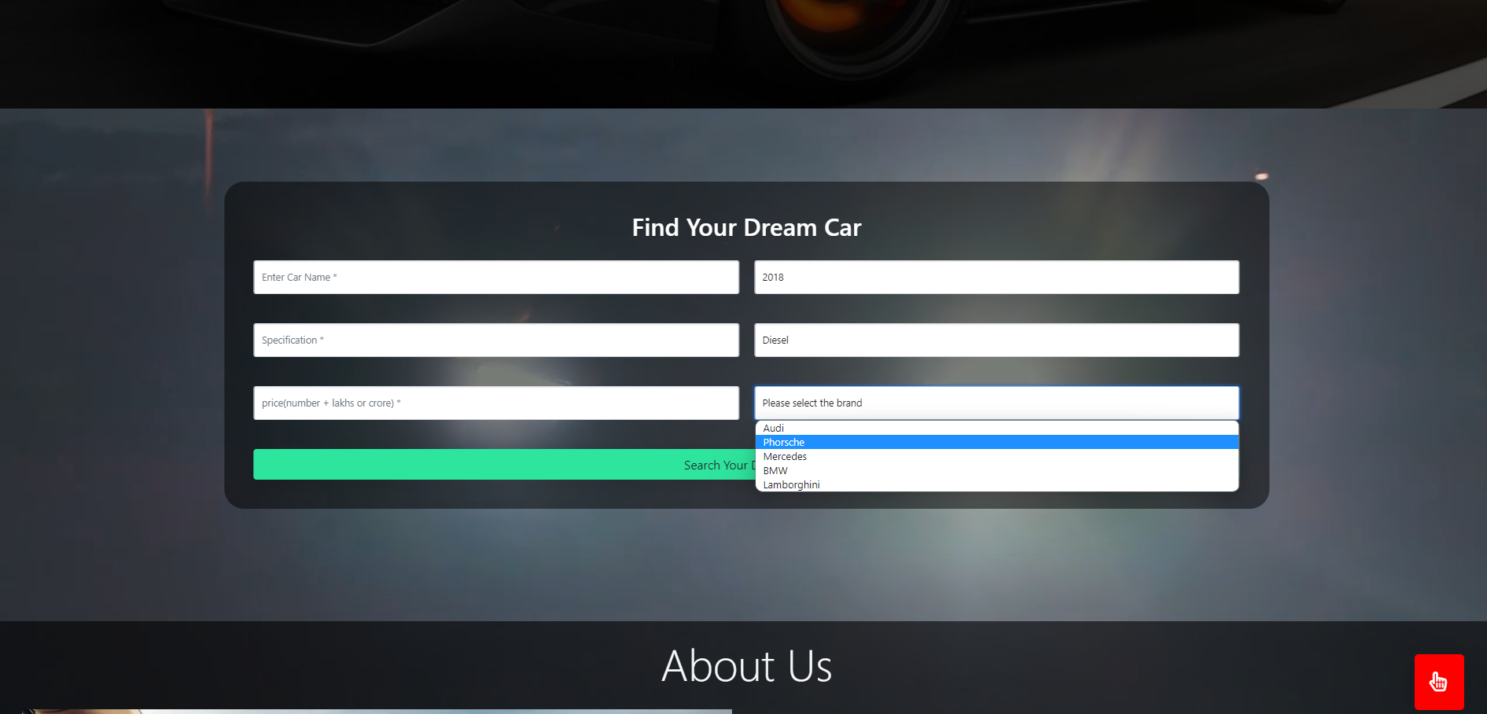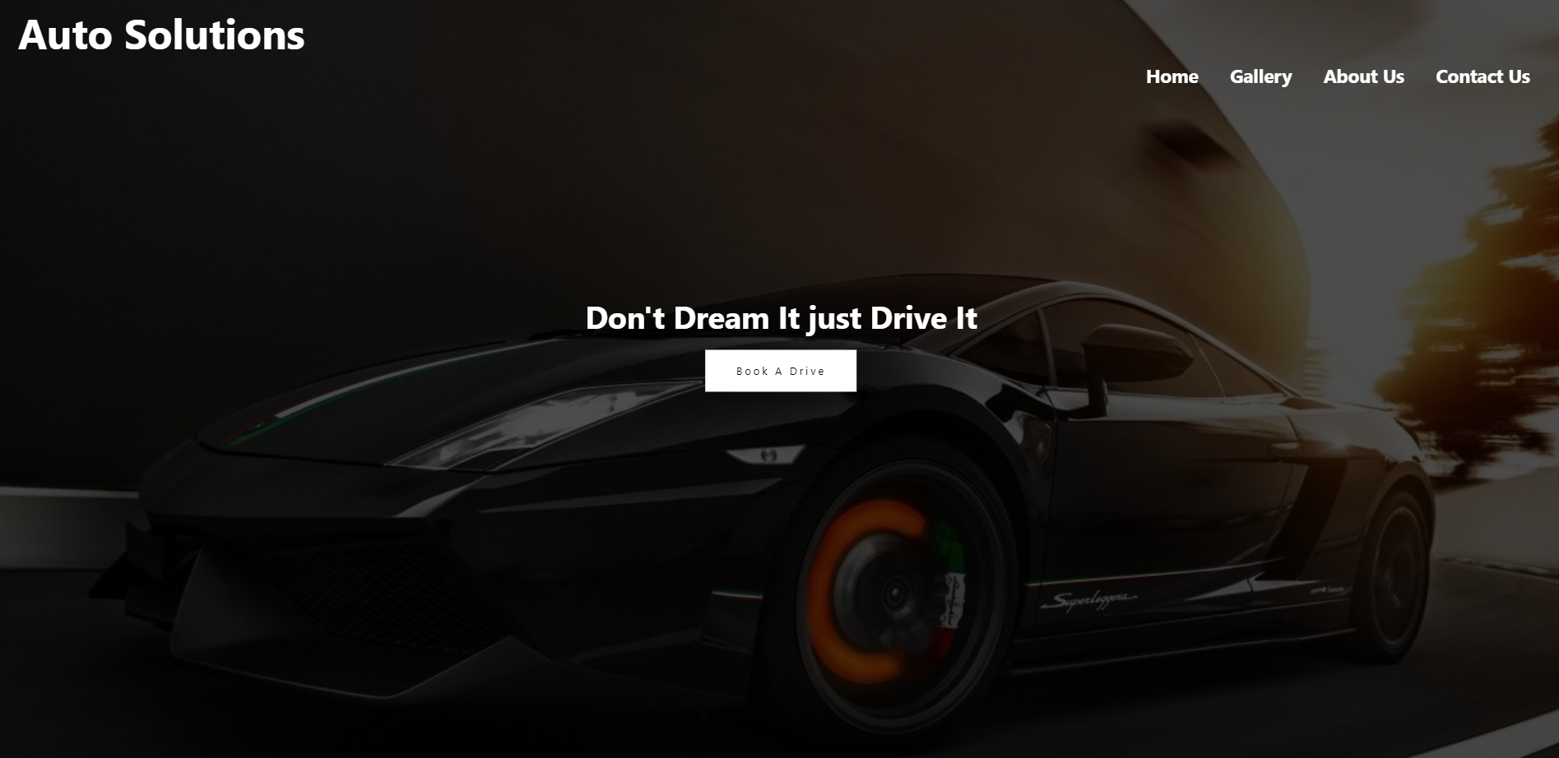Client Panel :-

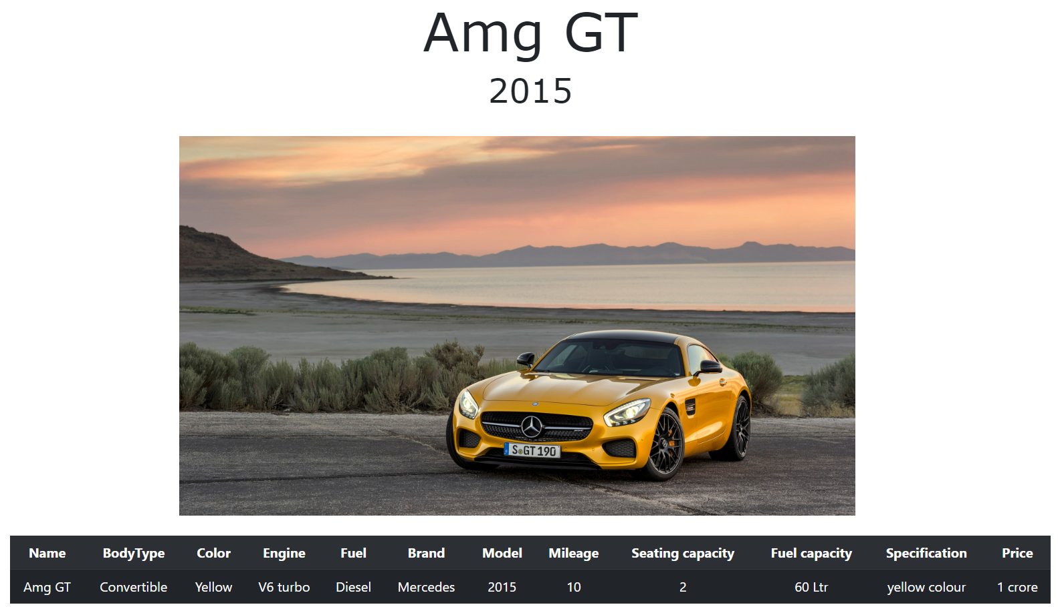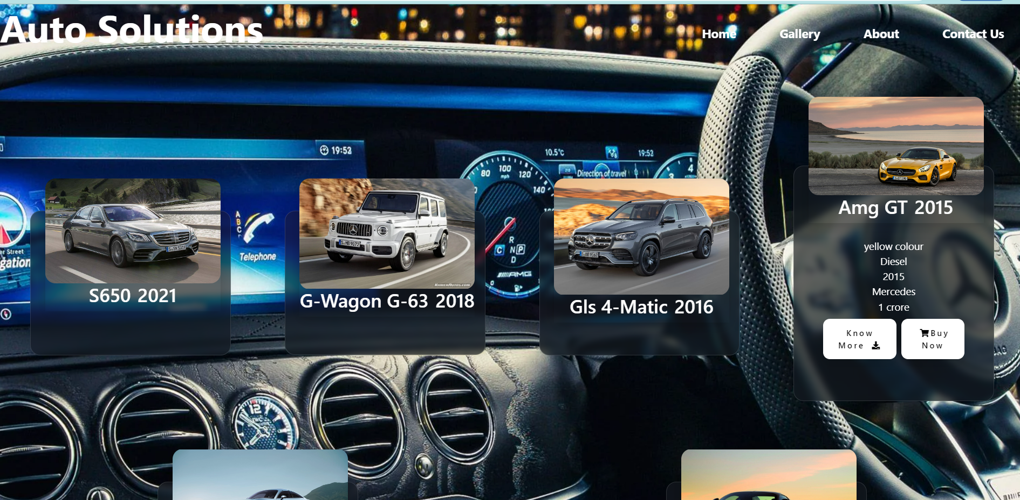

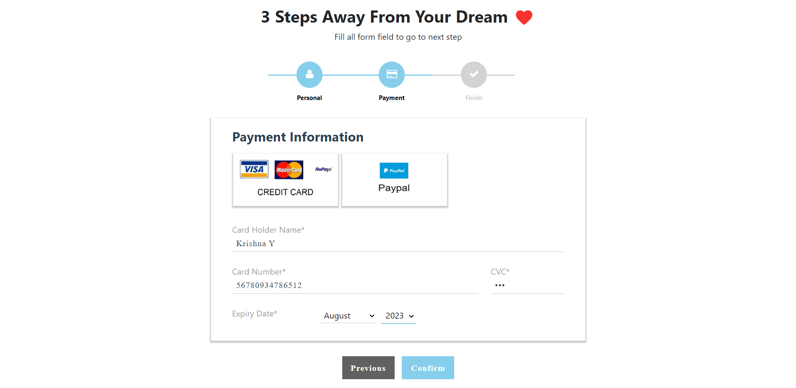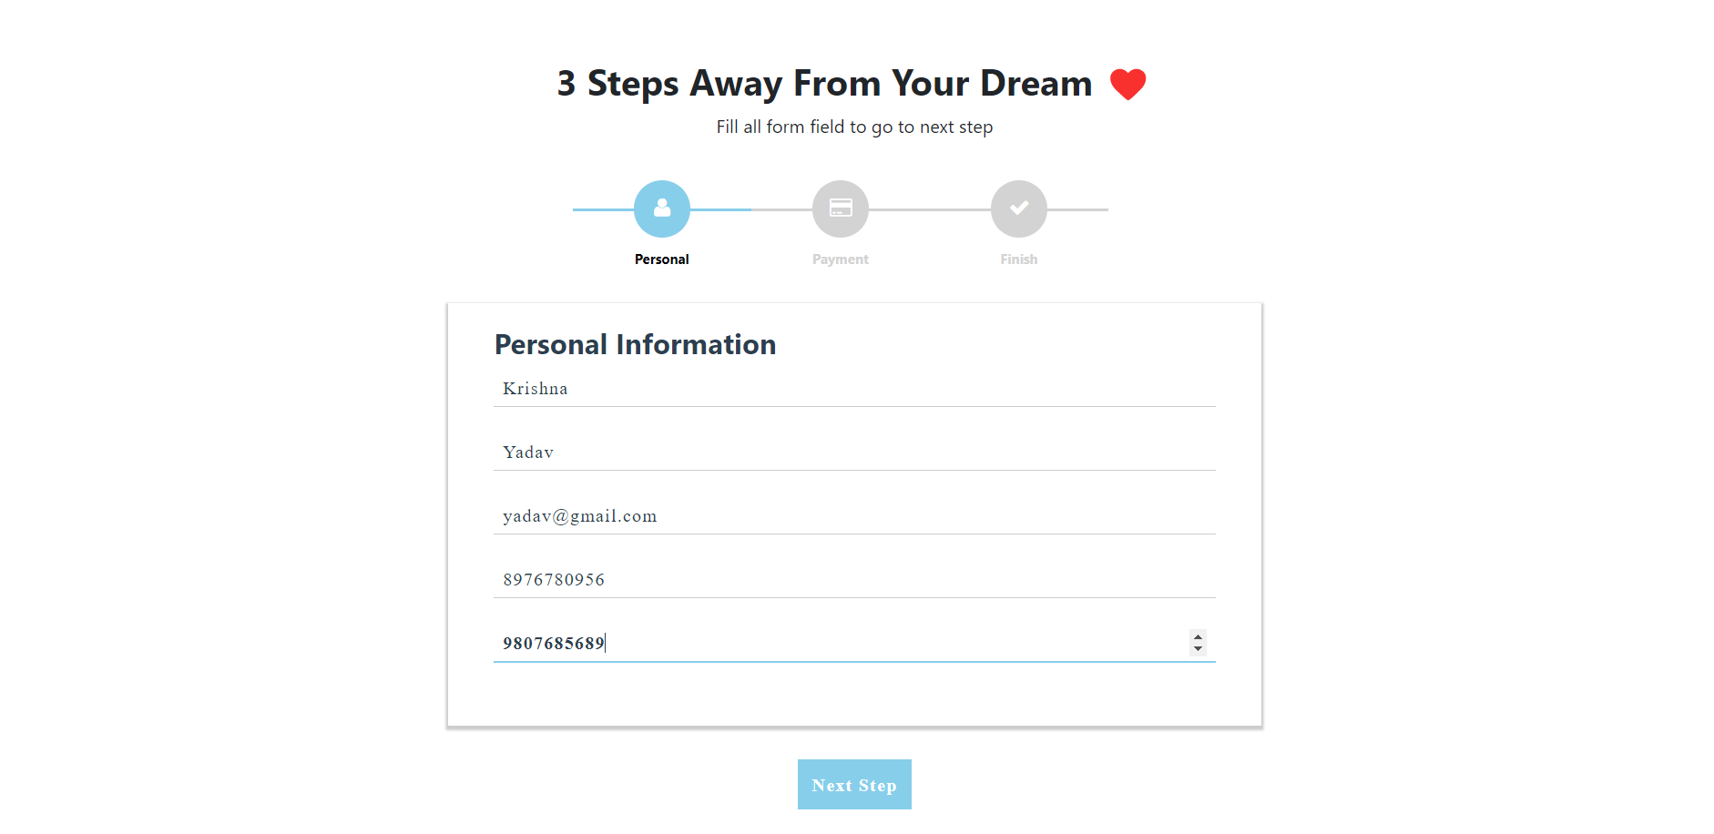

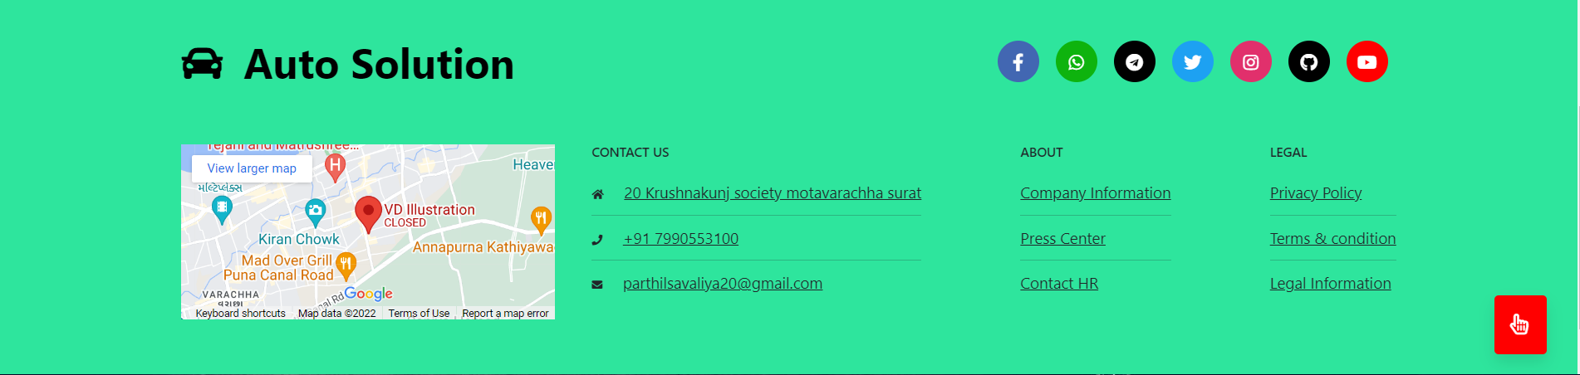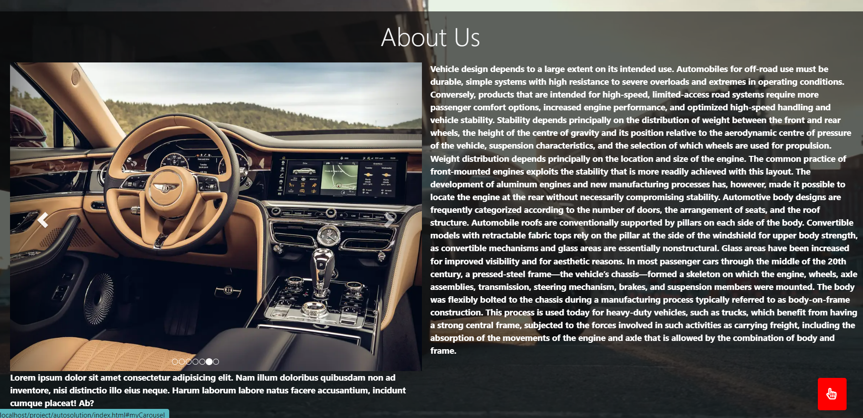

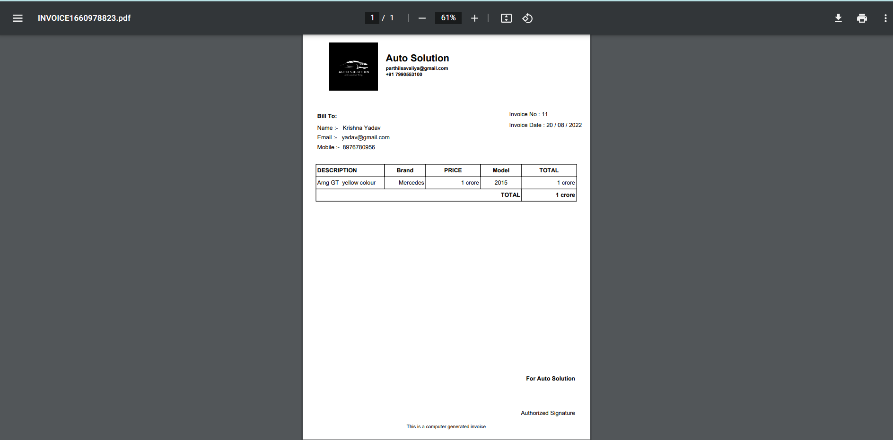

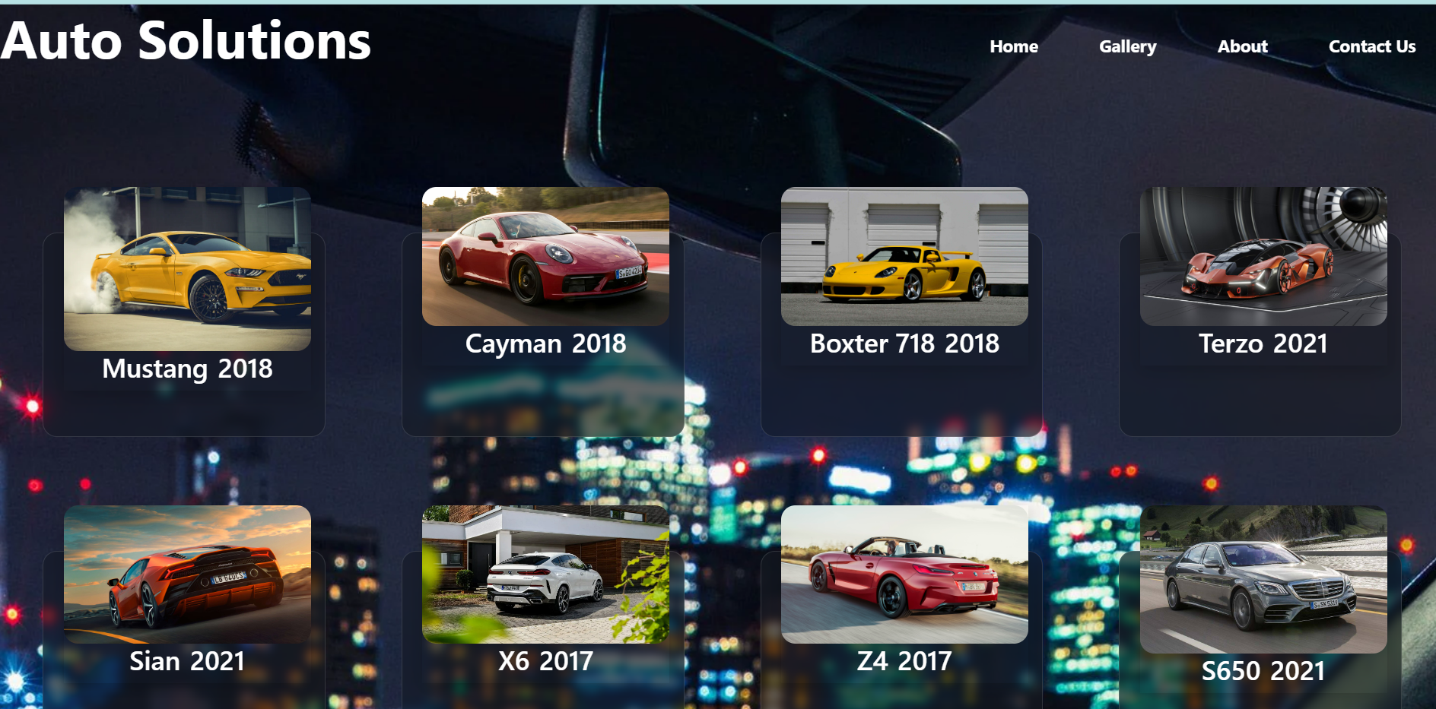

* Admin Panel :-

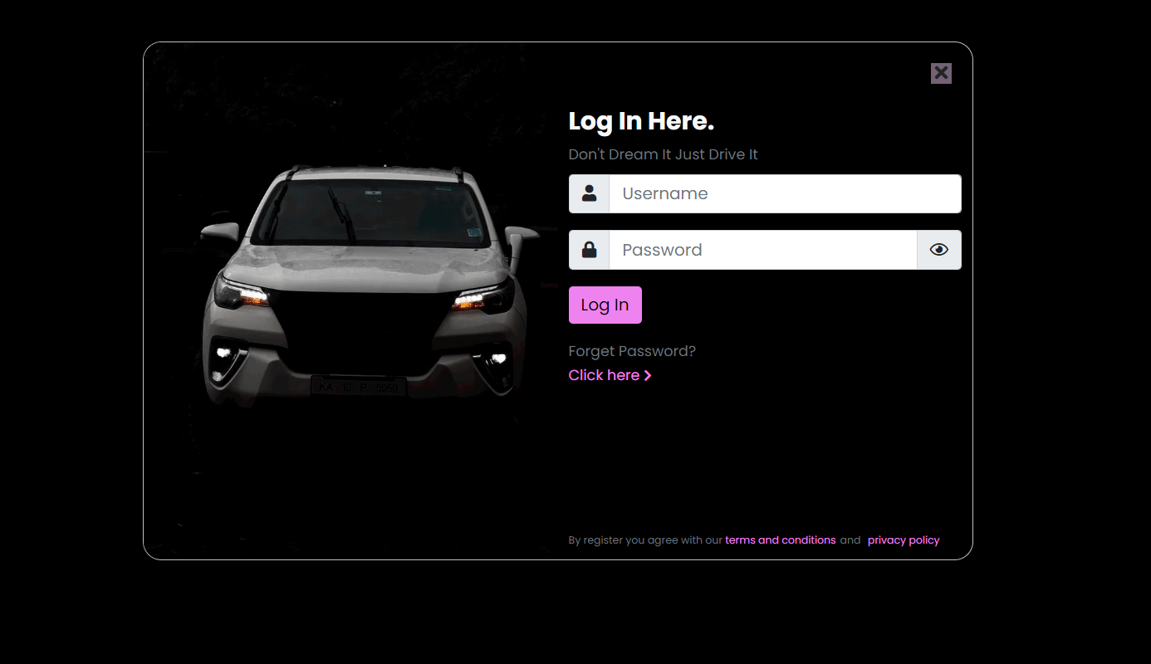

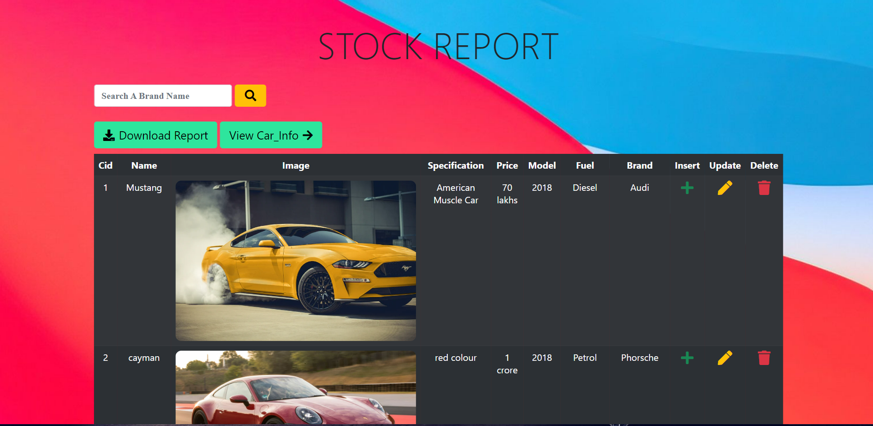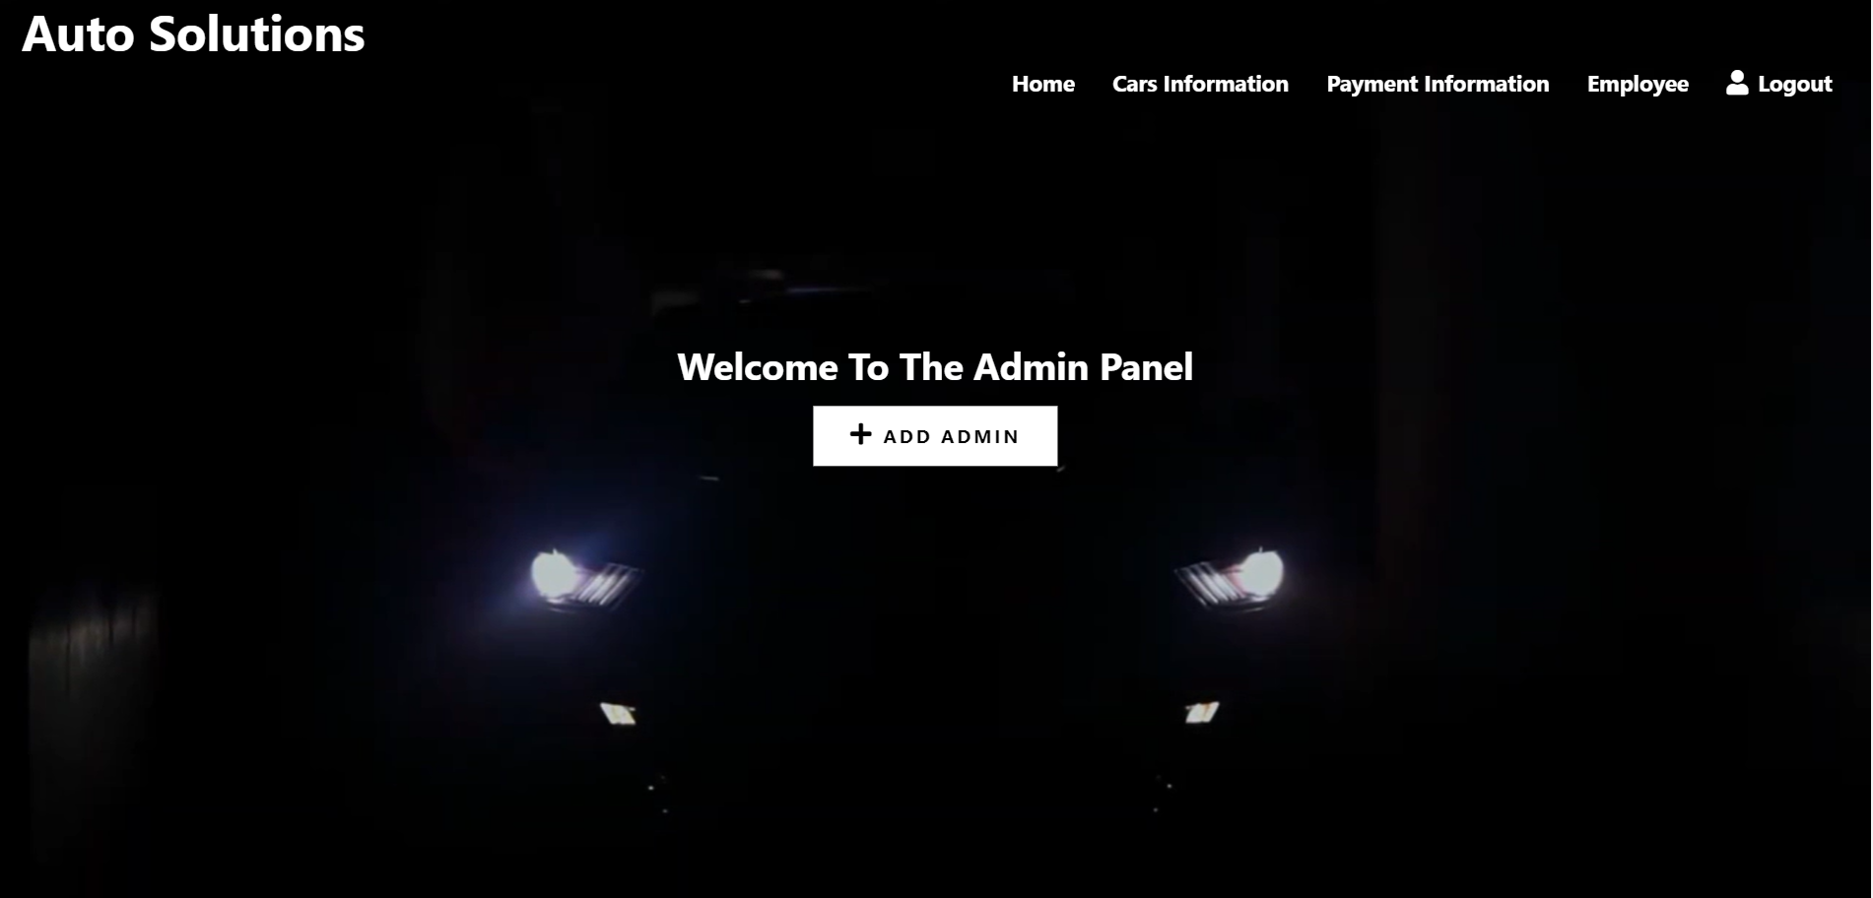

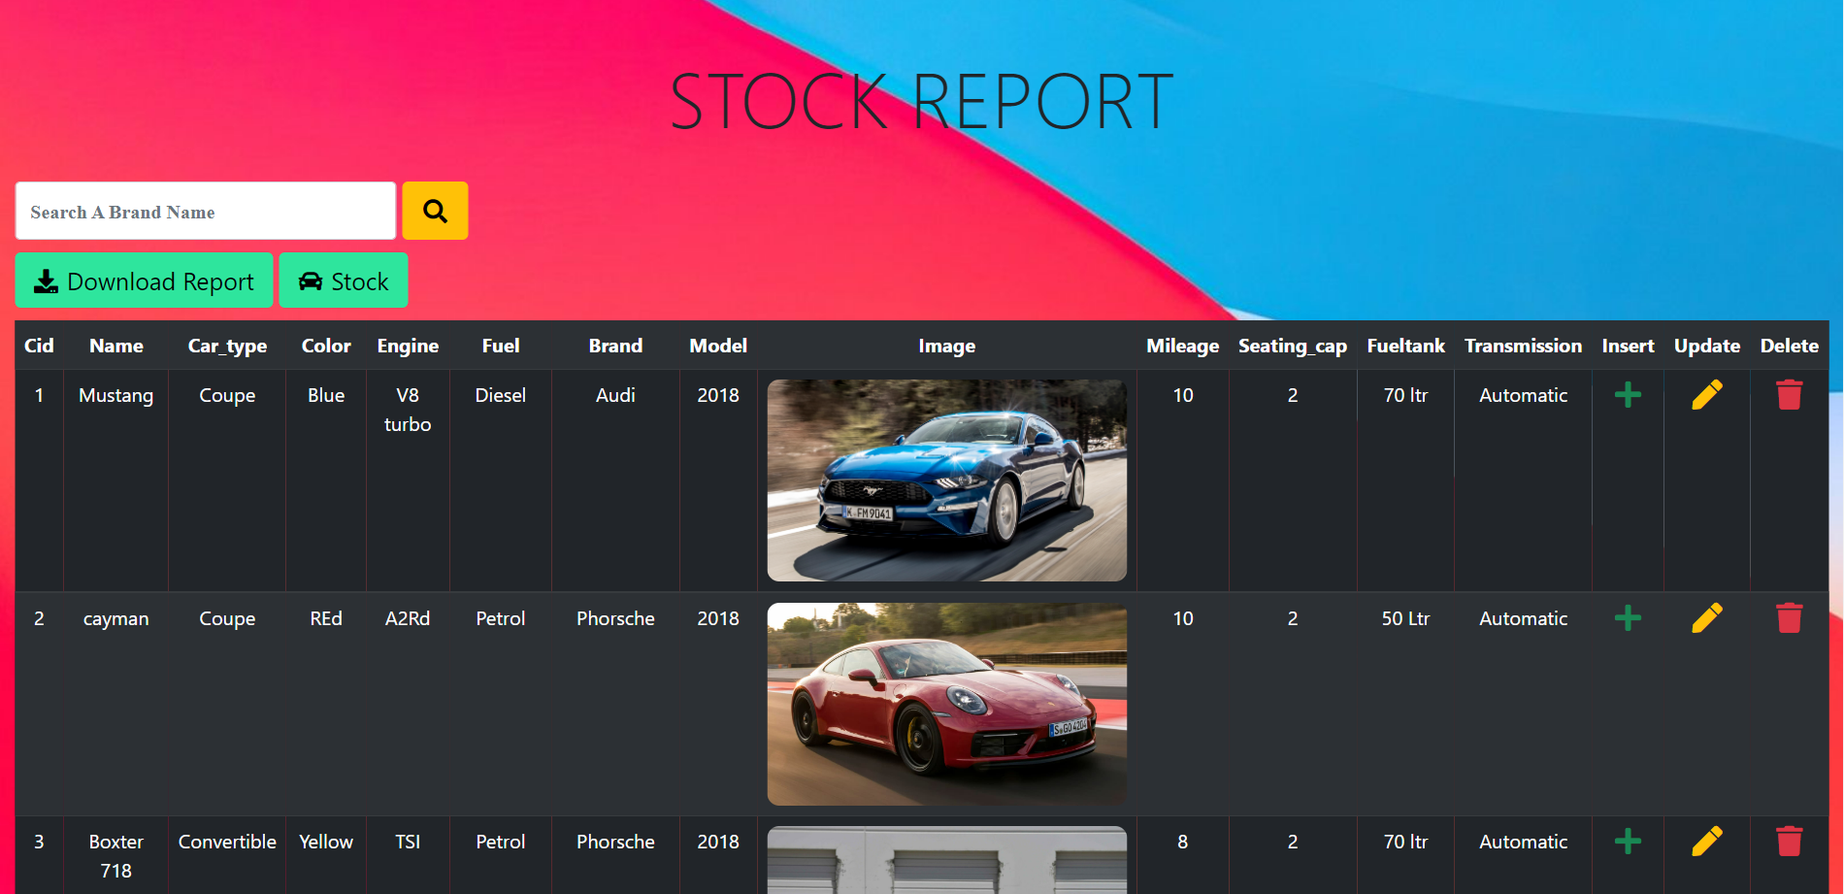

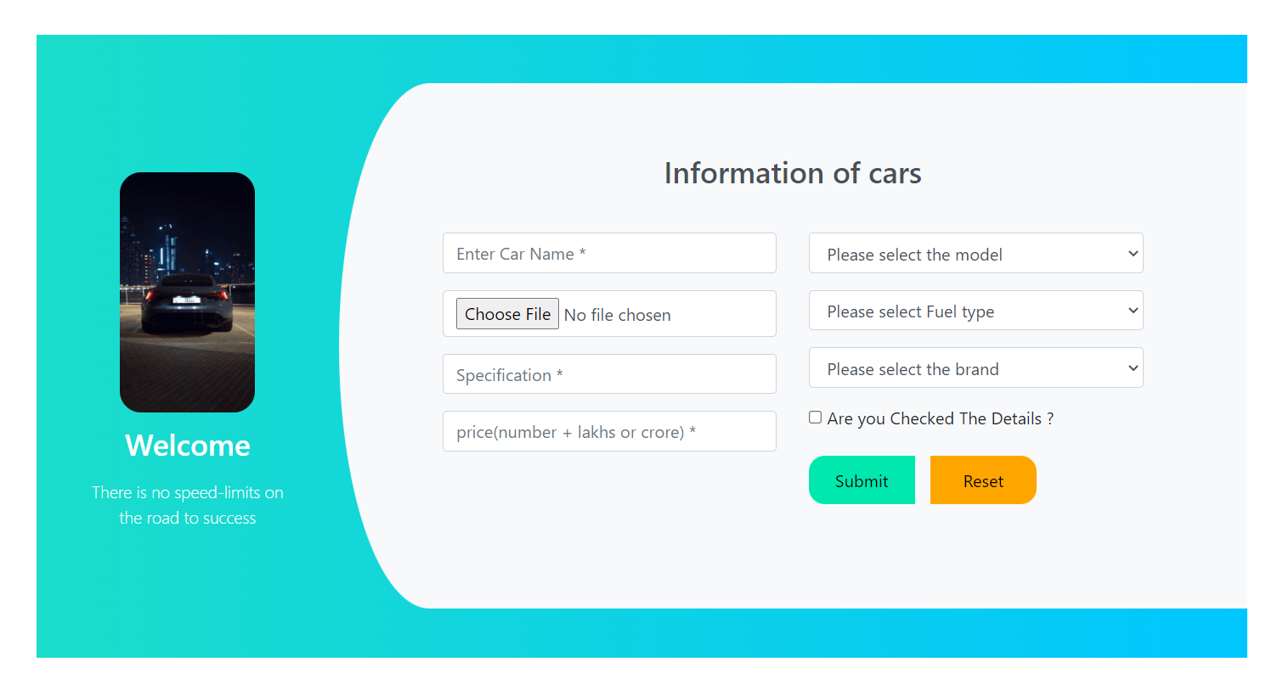

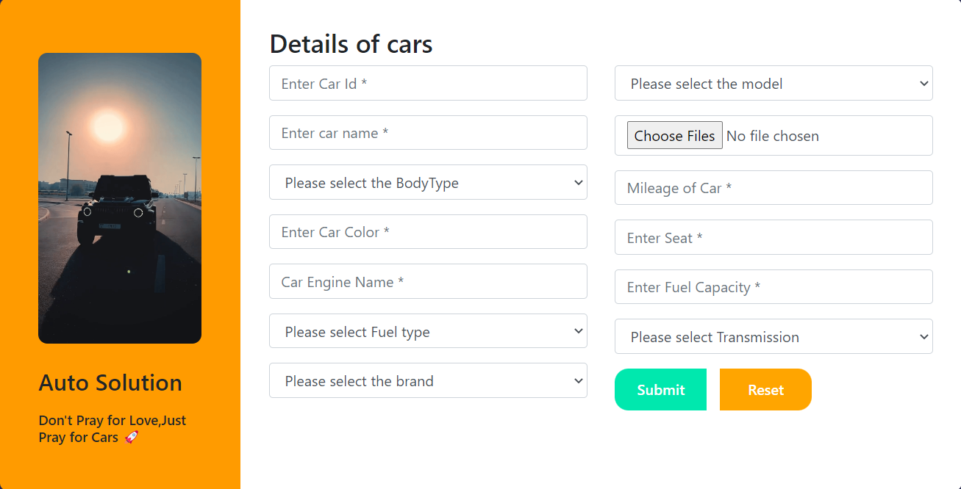

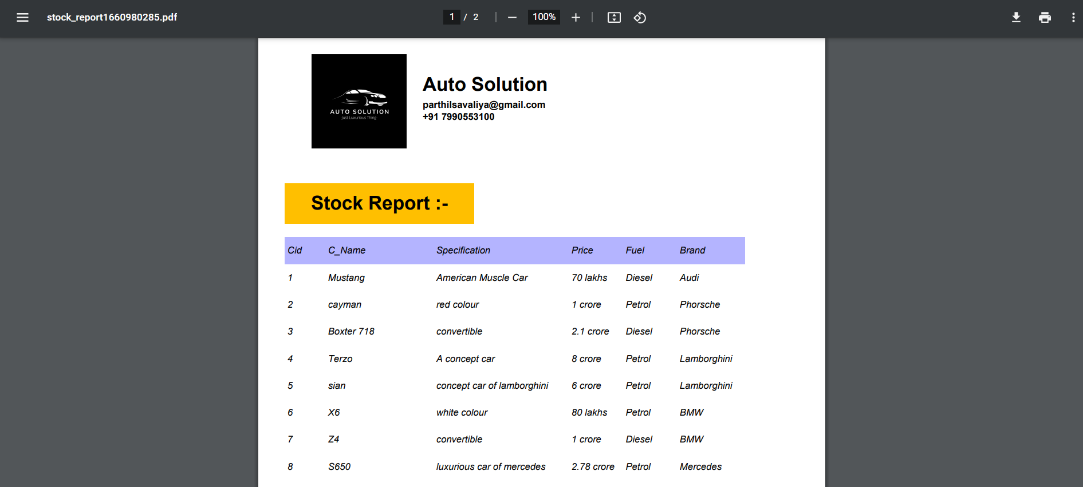

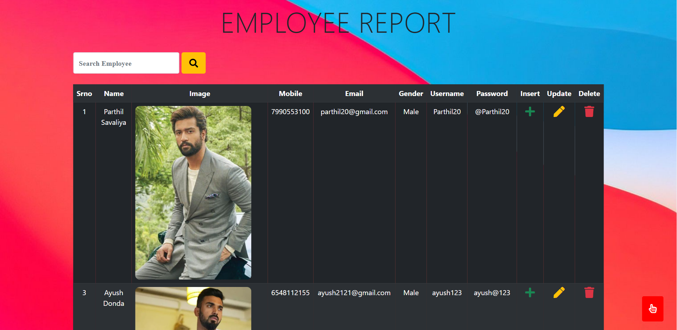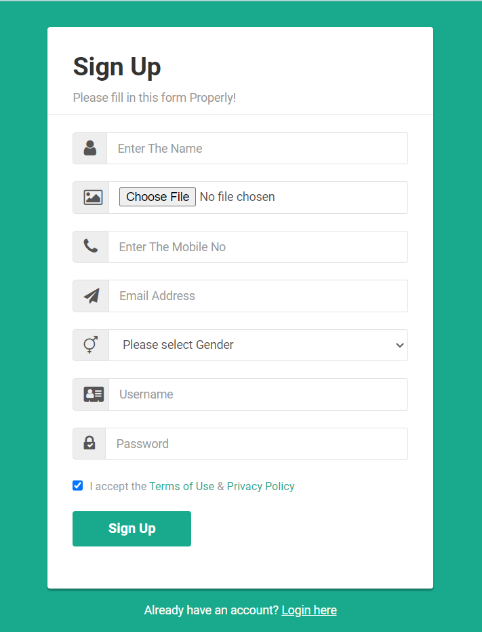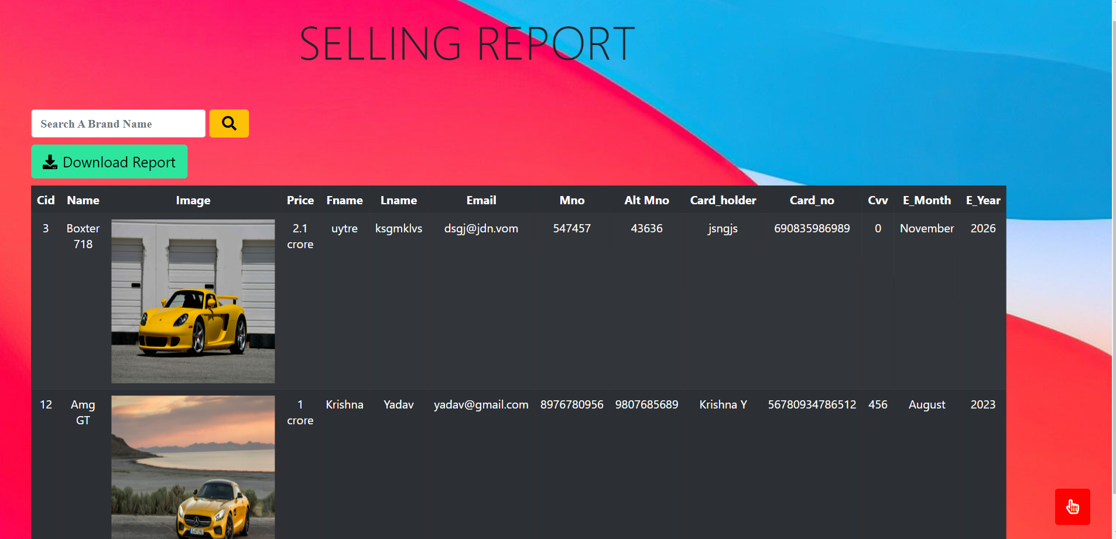

* References :-
* <http://www.fpdf.org/>
* <https://stackoverflow.com/>
* <https://www.w3schools.com/php/>
* <https://online.visualparadigm.com/app/diagrams/>
* <https://fontawesome.com/icons>
* <https://getbootstrap.com/>